lvl0-bandit0

lvl0-lvl1-boJ9jbbUNNfktd78OOpsqOltutMc3MY1



lvl1-lvl2-CV1DtqXWVFXTvM2F0k09SHz0YwRINYA9

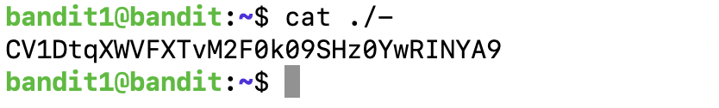

lvl2-lvl3-UmHadQclWmgdLOKQ3YNgjWxGoRMb5luK



lvl3-lvl4-pIwrPrtPN36QITSp3EQaw936yaFoFgAB



lvl4-lvl5-koReBOKuIDDepwhWk7jZC0RTdopnAYKh



lvl5-lvl6-DXjZPULLxYr17uwoI01bNLQbtFemEgo7



lvl6-lvl7-HKBPTKQnIay4Fw76bEy8PVxKEDQRKTzs



lvl7-lvl8-cvX2JJa4CFALtqS87jk27qwqGhBM9plV



lvl8-lvl9-UsvVyFSfZZWbi6wgC7dAFyFuR6jQQUhR



lvl9-lvl10-truKLdjsbJ5g7yyJ2X2R0o3a5HQJFuLk

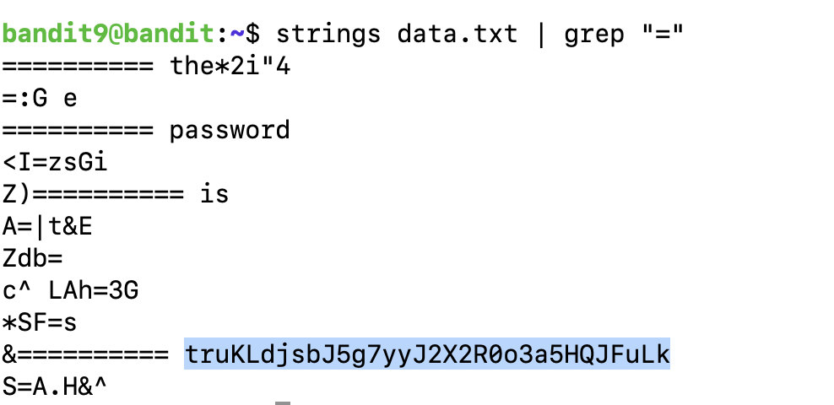

lvl10-lvl12-IFukwKGsFW8MOq3IRFqrxE1hxTNEbUPR



lvl11-lvl12-5Te8Y4drgCRfCx8ugdwuEX8KFC6k2Euu

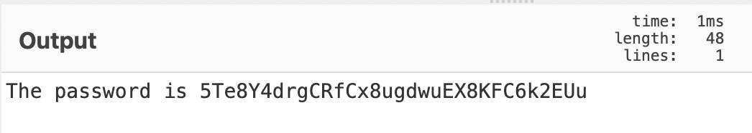

lvl12-lvl13-8ZjyCRiBWFYkneahHwxCv3wb2a1ORpYL



lvl13-lvl14-4wcYUJFw0k0XLShlDzztnTBHiqxU3b3e



lvl14-lvl15-BfMYroe26WYalil77FoDi9qh59eK5xNr

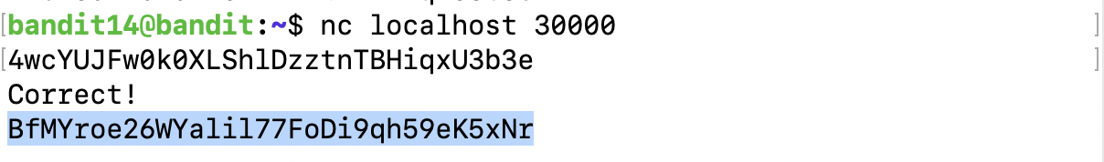

lvl15-lvl16-cluFn7wTiGryunymYOu4RcffSxQluehd

